BrainStorming:

* Users/Auth
* Public/Private Recipes
* Ingredients
* Grocery Lists
* Occasions
* Saved Recipes

Relationships:

One to One:

USER TABLE – AUTH TABLE ; Sign in! One user to one password

One to Many:

User - Recipes :one user creates many recipes

Grocery List - Ingredients : one list w/ many ingred.

Grocery List - Recipes: one list w/ many Recipes

Grocery List - Occasions: one list w/ many Occasions

Many to Many:

User to Occasion, User-Occasion* many users can access many occasions

Ingredient - Recipes :Recipe-Ingredients Many ingredients used in many recipes

Recipes - Occasions:Occasion-Recipes Many recipes can be added to many occasions

Recipes -User Recipes* Users

Tables:

User*

Auth*

Grocery list*

Ingredient*

Recipe*

Occasion*

Saved Recipe*

User-occasion

Recipe-Ingredients

Occasion-Recipes

User-Recipes

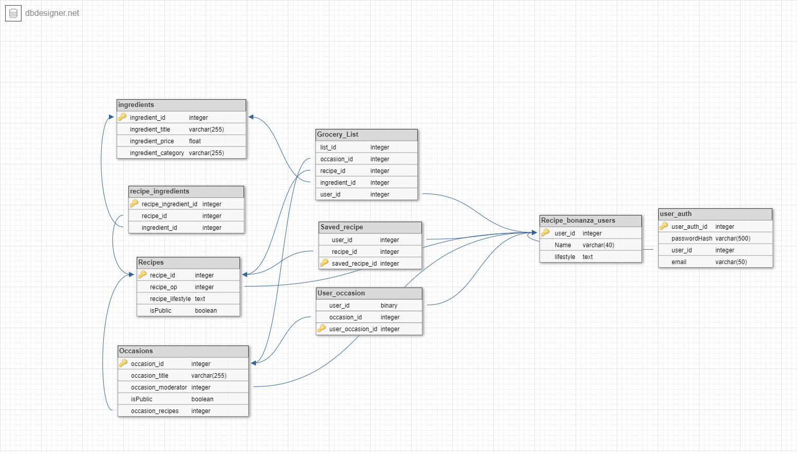

**Ingredients**:

Id - identify

Title - to see name/ varchar to have a set amount of characters to list the product

Price - for totaling lists/ float works best here because sales tax

Category - type of ingredient/ add in whether something is a fruit,

**recipe - ingredients**:

Middle man for

Recipe_id and Ingredients_id

**Recipes**:

Recipe_id - identification /id are numbers

Recipe_op-To save the user who added the recipe /link to id_user

Recipe_lifestyle- weather the recipe is vegan/vegetarian etc. /char used because type is natural lang.

isPublic- is a boolean to say weather the recipe is intended to be public or private

**Occasions**:

Id - identify

Title - natural language

Moderator - special access

isPublic - private or public

Occasion-recipes: to link to recipes i

**Grocery_List**:

List_id: find list

Occasion_id: link to occasion integer cuz integer

Recipe_id: foreign id/ to link with the recipe

Ingredient_id: foreign id/ to link with the ingredient

User_id: foreign id/ to link with the user

**Saved_recipes**:

Saved_recipe_id: identification/serial

User_id: foreign id/ to link with the user

Recipe_id: foreign id/ to link with the recipe

**User_occasion:**

User_occasion_id: serial/ identification

User_id: foreign id/ to link with the user

occasion_id: foreign id/ to link with the recipe

**Recipe_bonanza_users**:

User-id: serial/ used for identification

Name: used for the user’s name

Lifestyle: the user inputs his preferred lifestyle like vegan,etc.

**User_auth**:

User_auth_id: way to access id

Password Hash : used for storing hashed password char because will contain letters and numbers

User_id: foreign id/ to link with the user

Email: unique username;char to store emails

CREATE TABLE Recipe_bonanza_users (

user_id SERIAL PRIMARY KEY,

names varchar(40),

lifestyle varchar(140)

) ;

CREATE TABLE user_auth (

user_auth_id SERIAL PRIMARY KEY,

passwordHash varchar(500),

user_id integer NOT NULL REFERENCES, Recipe_bonanza_users(user_id)

email varchar(50)

);

CREATE TABLE ingredients (

ingredient_id SERIAL PRIMARY KEY,

ingredient_title varchar(255),

ingredient_price FLOAT,

ingredient_category varchar(255)

);

CREATE TABLE Recipes(

recipe_id SERIAL PRIMARY KEY,

recipe_op integer,

recipe_lifestyle varchar(255),

isPublic BOOLEAN

);

CREATE TABLE Occasions (

occasion_id SERIAL PRIMARY KEY,

occasion_title varchar(255),

occasion_moderator integer NOT NULL REFERENCES, Recipe_bonanza_users(user_id)

isPublic BOOLEAN,

occasion_recipes SERIAL PRIMARY KEY

);

CREATE TABLE Grocery_List (

list_id SERIAL PRIMARY KEY,

occasion_id integer NOT NULL REFERENCES, Occasions(occasion_id),

recipe_id integer NOT NULL REFERENCES, Recipes(recipe_id),

ingredient_id integer NOT NULL REFERENCES, ingredients(ingredient_id),

user_id integer NOT NULL REFERENCES, Recipe_bonanza_users(user_id)

);

CREATE TABLE Saved_recipe (

user_id integer NOT NULL REFERENCES, Recipe_bonanza_users(user_id),

recipe_id integer NOT NULL REFERENCES, Recipes(recipe_id),

saved_recipe_id SERIAL PRIMARY KEY

);

CREATE TABLE User_occasion (

user_occasion_id SERIAL PRIMARY KEY

user_id integer NOT NULL REFERENCES, Recipe_bonanza_users(user_id),

occasion_id integer NOT NULL REFERENCES, Occasions(occasion_id)

);

CREATE TABLE recipe_ingredients (

recipe_ingredient_id SERIAL PRIMARY KEY,

recipe_id integer NOT NULL REFERENCES, Recipes(recipe_id),

ingredient_id integer NOT NULL REFERENCES, ingredients(ingredient_id),

);